Log-In Page:
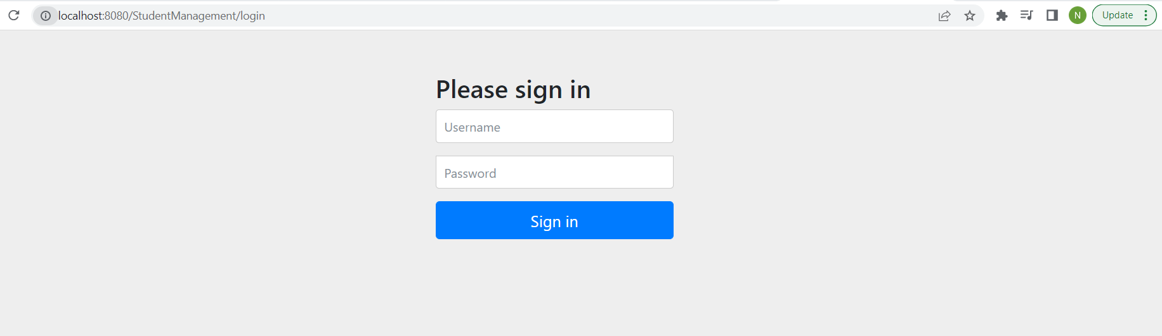
Logged In with ADMIN Role User:
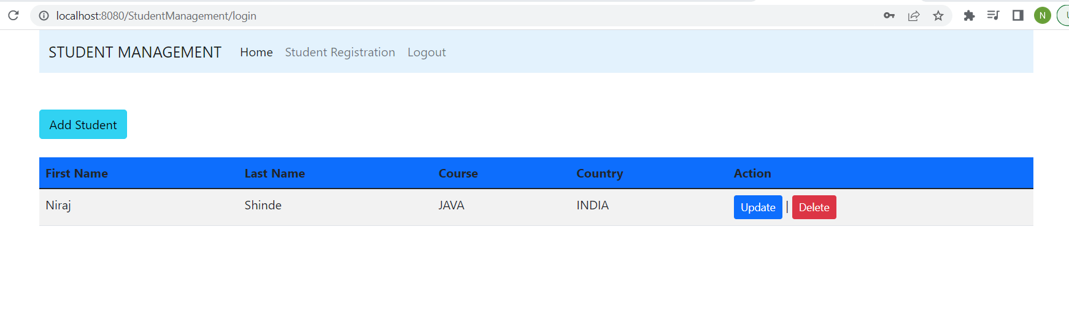
Add Student Form:
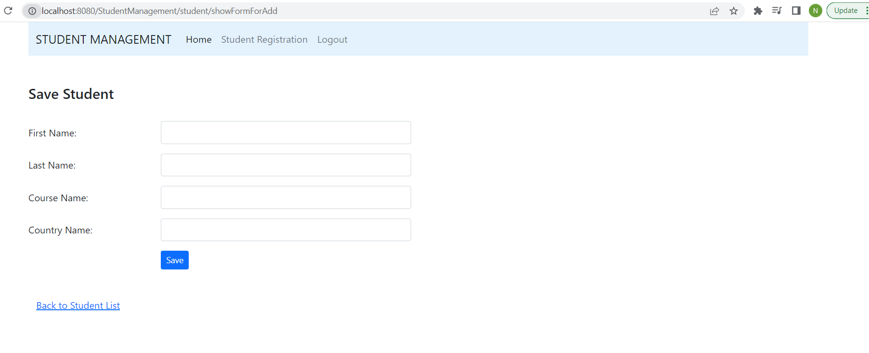

Add Student Form Validations:
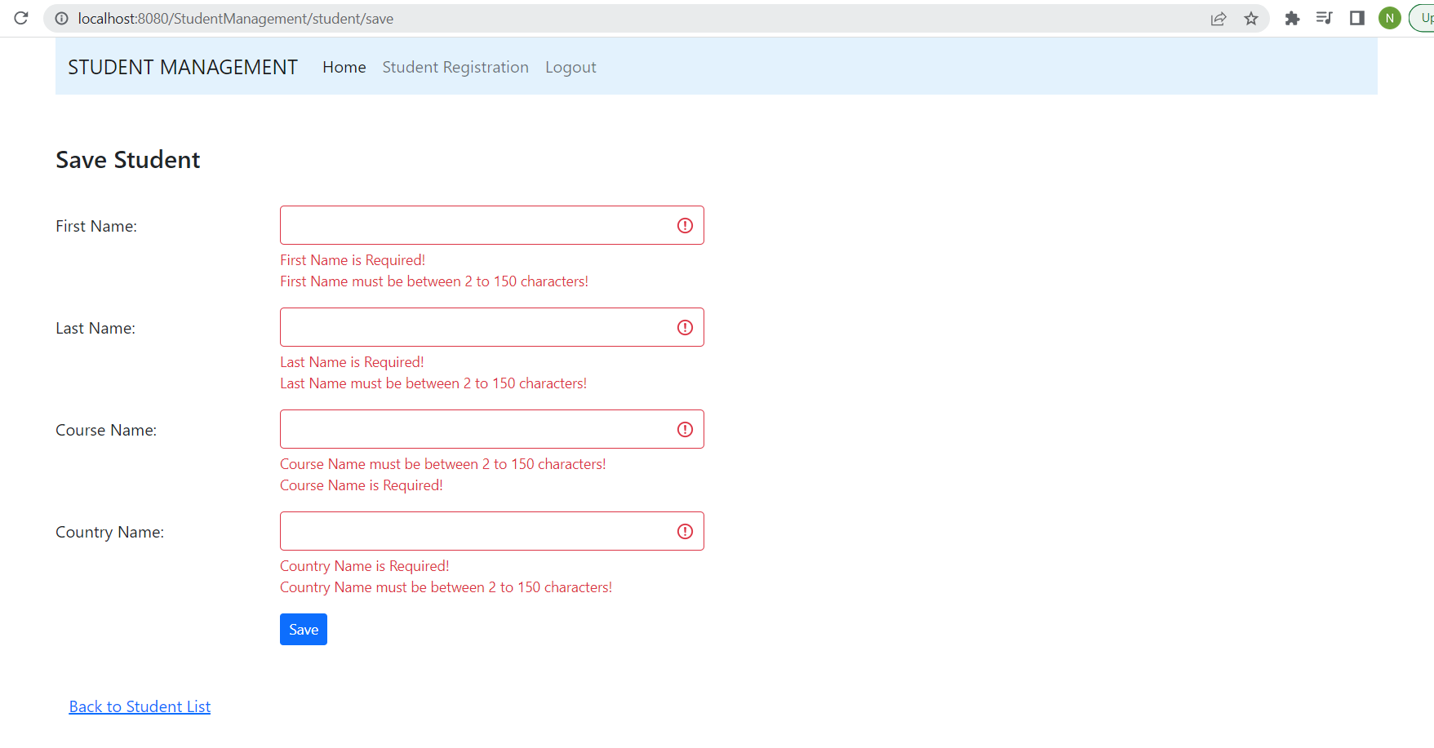

After Adding new Student User get redirected to User List Page:
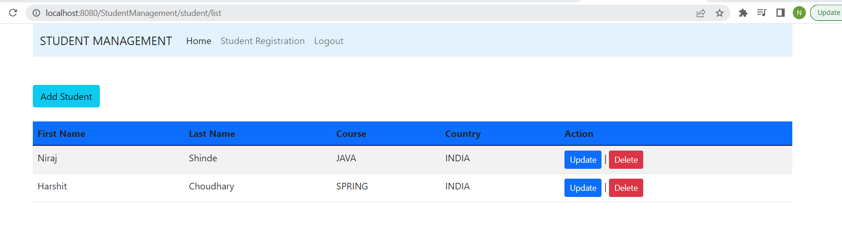
Delete Student Confirmation:
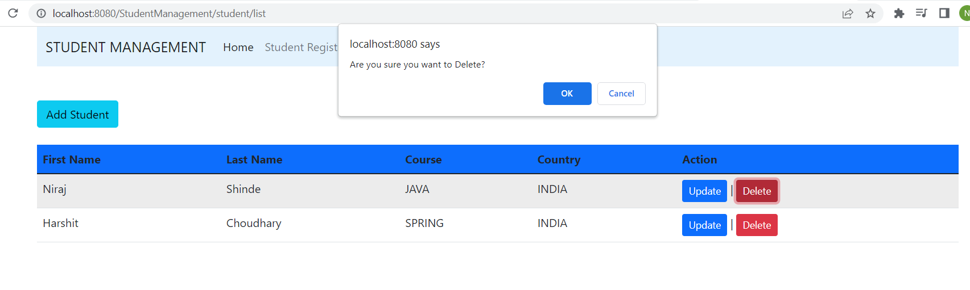

Delete Student Success:
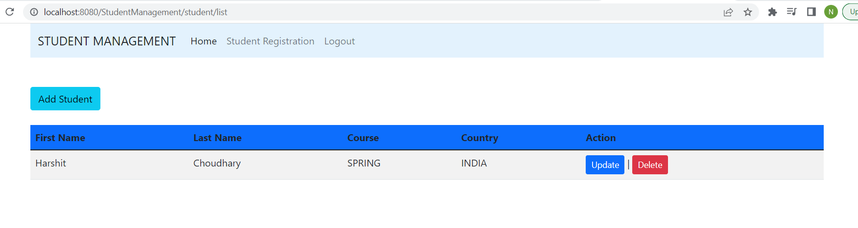
Update Student Form:
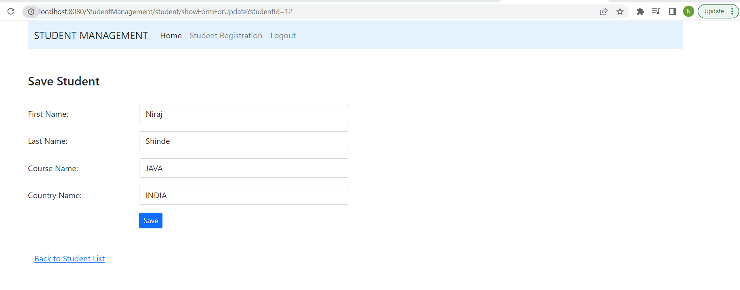
Update Student form Validation:
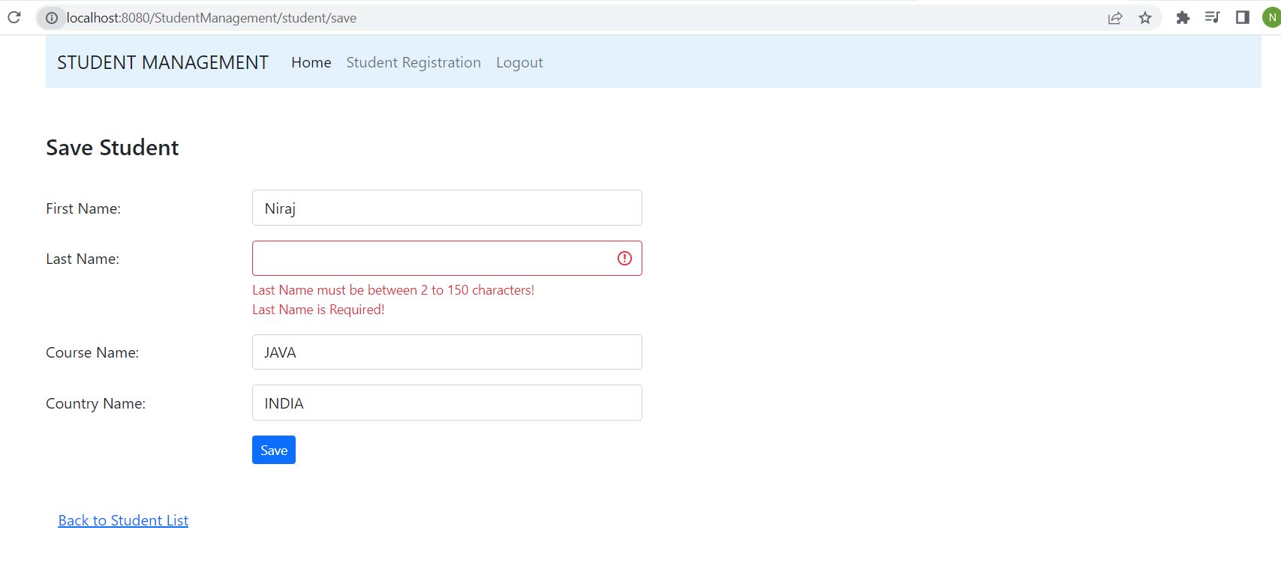

Logged in with USER Role: (this user does not have access to update and delete Student)
